# Free Measurements

Requirements?

# Photocurrent vs. Wavelength

## Devices used:

* SMU (Keithley 2600)
* LIA (SRS 810)
* OPM (PM400)
* OPA (Orpheus HP)

## Input parameters:

### SMU

* SMU fixed voltage, V
* SMU Channel

### LIA Do you need the ability to set these parameters? or stay defaults (checked)

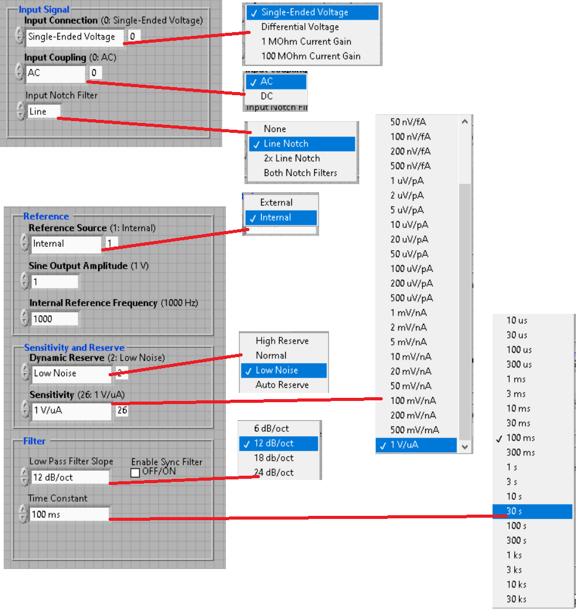

### OPA

* OPA Start wavelength, nm
* OPA Stop wavelength, nm
* OPA Scan resolution, nm *or* Number or points

### Measurements

* Integration time, sec
* Delay time, ms
* Accumulation

## Algorithm:

1. Set SMU output **voltage**
2. Set SMU **output** enabled
3. Set OPA output signal **wavelength**
4. Set OPM wavelength
5. OPA **open** shutter
6. Wait **integration time**
7. Measure SMU Current, A (repeatedly **Accumulation** times and get average)
8. Measure LIA Magnitude (repeatedly **Accumulation** times and get average)
9. Wait **Delay time**
10. Repeat steps 3-8 until not **Stop wavelength** reached
11. OPA **close** shutter

# I-V Curve

### Devices used:

* SMU (Keithley 2600)
* LIA (SRS 810)
* OPM (PM400)
* OPA (Orpheus HP)

### Input parameters:

### Algorithm:

# Photocurrent mapping

### Devices used:

### Input parameters:

### Algorithm: